For Employees
Time Off Request and Approval Workflow
SUMMARY
The purpose of this module is to make viewing leave balances, requesting time off, and tracking approvals simple and transparent. Available balances are clearly displayed in days and hours, carry-forward leaves automatically reflect expiration dates, and automated email notifications keep employees and approvers updated throughout the process.
PROCEDURE
Step 1 – Check available balance and allocation expiry on the Time Off dashboard.
Step 2 – Submit a time off request with selected leave type and dates.
Step 3 – Manager and HR officer review and approve the request.
Step 4 – Employee receives automated confirmation email.
USER GUIDE
Step 1. Viewing leave balance and dashboard
Go to the Time Off module from the main menu.
On your dashboard, you will see your available balance for each leave type displayed in days and hours (e.g., 4 days 4 hours).
If you have carried-over leaves, the expiration date is displayed directly on the card (e.g., 3 days valid until 30-04-2027).
Click the info icon on any card to view a detailed breakdown of your allocations.
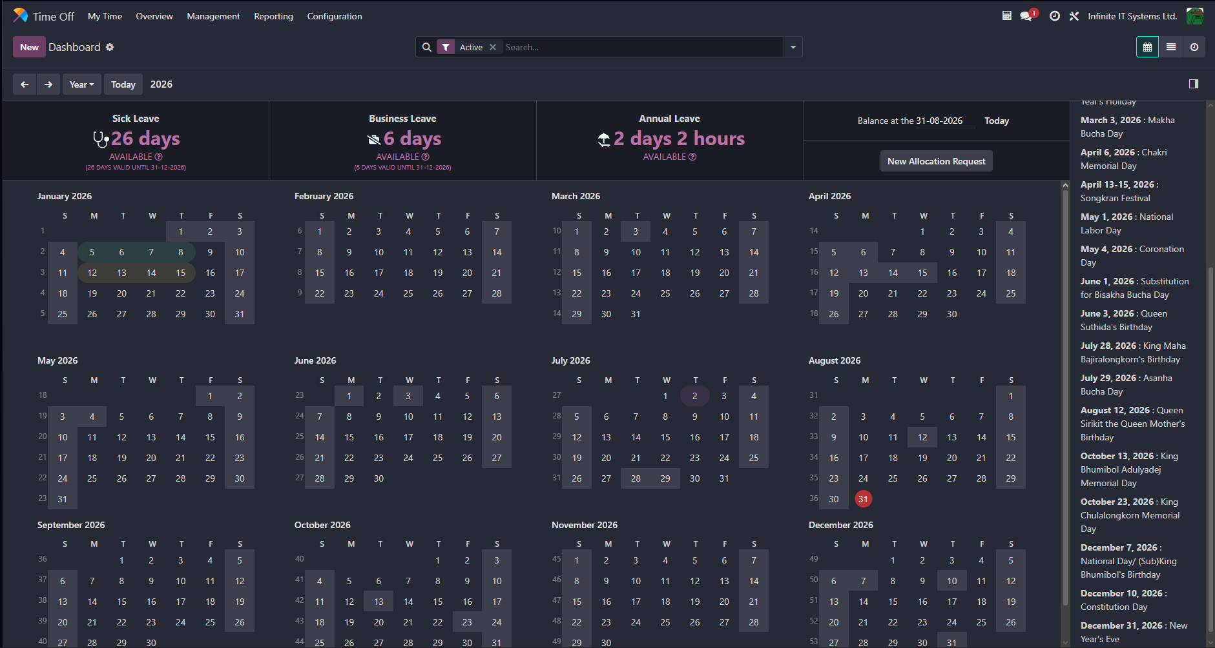
Step 2. Submitting a time off request
From the Time Off dashboard, click "New" (or click and drag across the calendar dates).
Select the "Time Off Type" (e.g., Paid Time Off, Sick Leave, Unpaid Leave).
Select the "From" and "To" dates. For partial days, choose "Half Day" (Morning or Afternoon).
Enter a reason or note for your manager in the "Description" field.
Click "Save" to submit your request for approval.
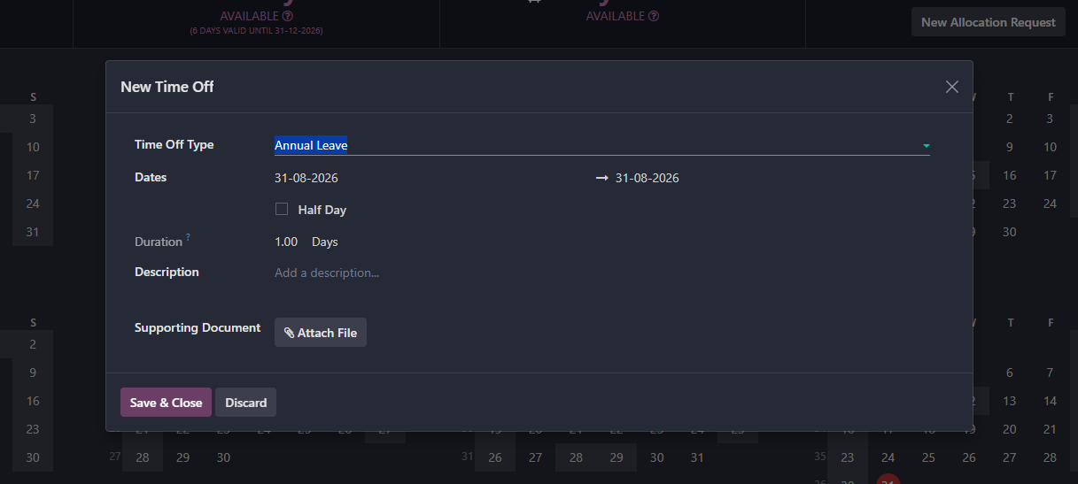
Step 3. Tracking your request status
Go to "My Time Off" -> "My Requests" (or check your dashboard calendar).
You can monitor the status of your request:
• To Approve: Waiting for your direct manager to review.
• Second Approval: Approved by manager, waiting for HR officer validation.
• Approved: Your leave is confirmed and approved.
• Refused: Your request was rejected.
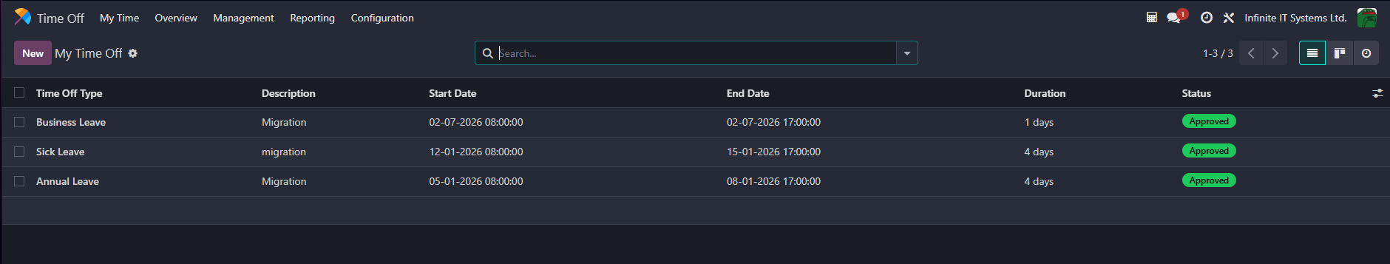

Step 4. Email notifications
When your request is approved, you will receive an automated email notification: "Time Off Approved".
If your request is refused, you will receive an automated email notification: "Time Off Refused".
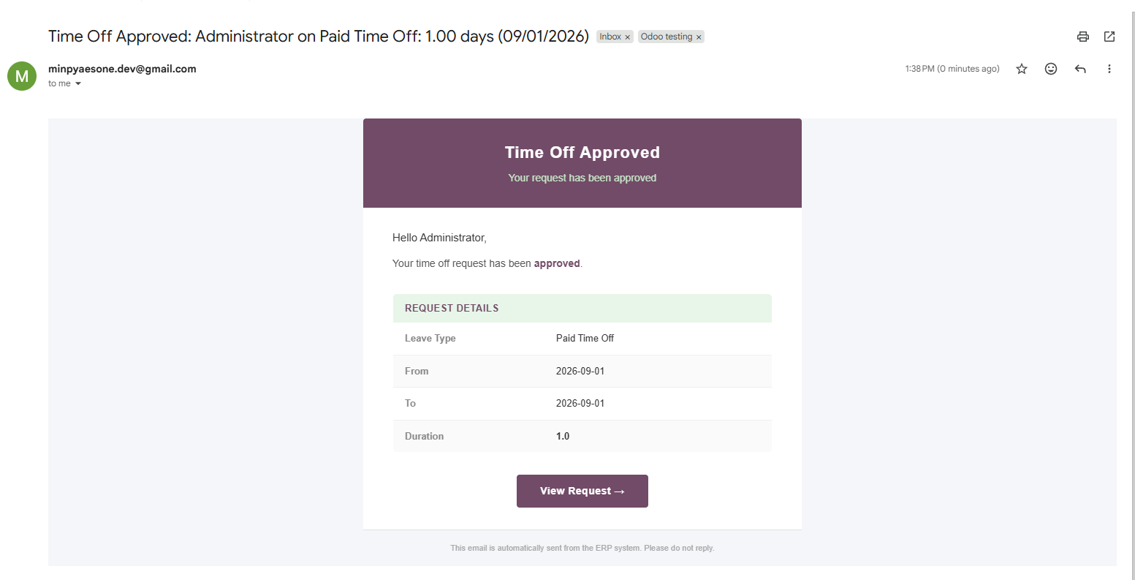

Step 5. Modifying or cancelling a request
Before approval (Status: "To Approve"): Click on your request to edit the dates/details, or click "Delete".
After approval (Status: "Approved"): Contact your manager or HR department to cancel or adjust an approved leave.

